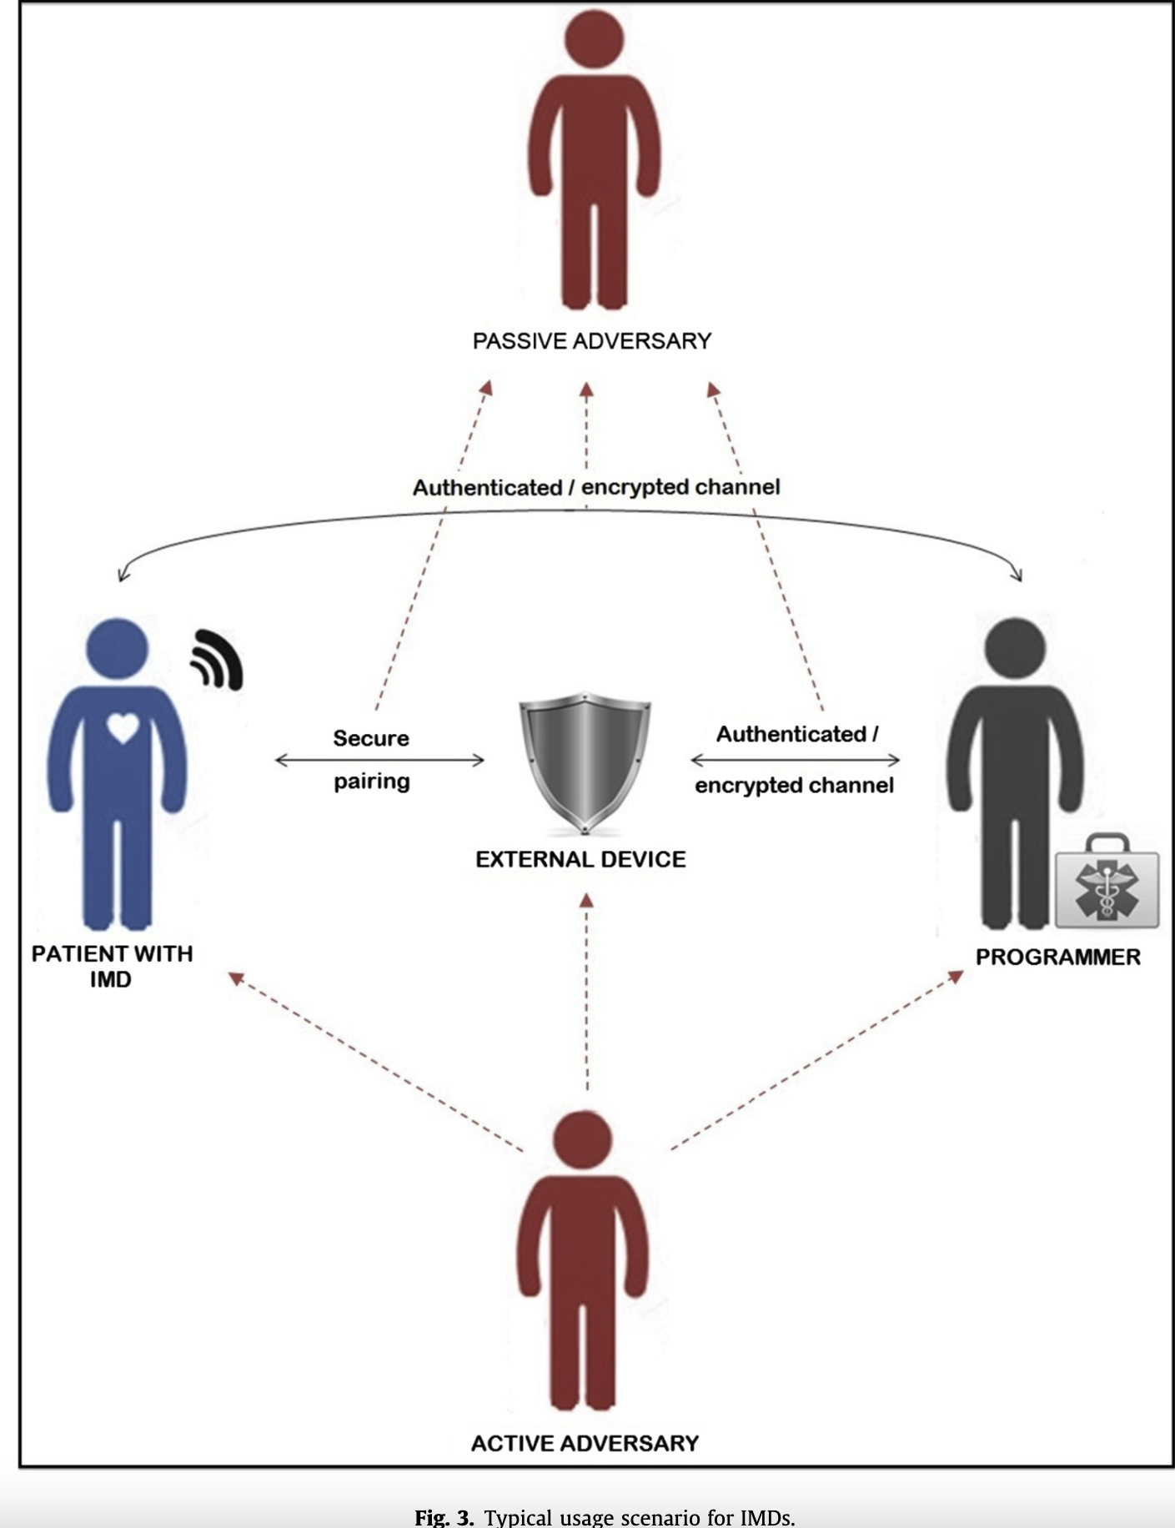
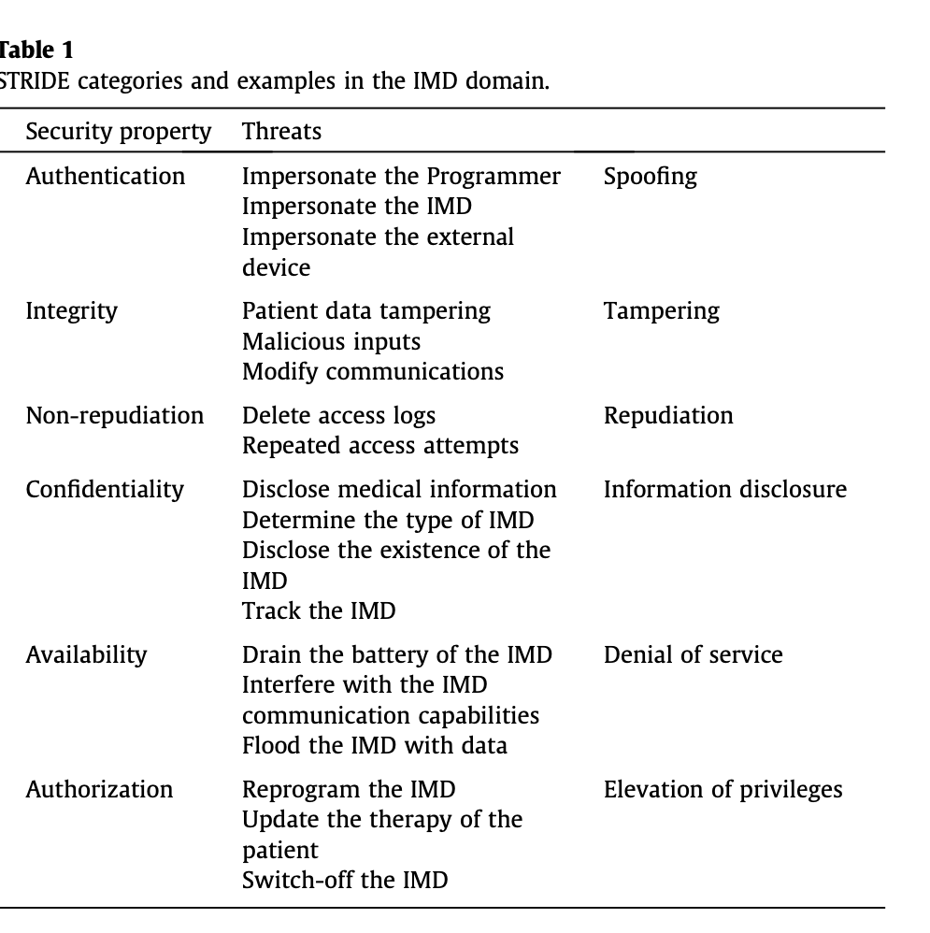
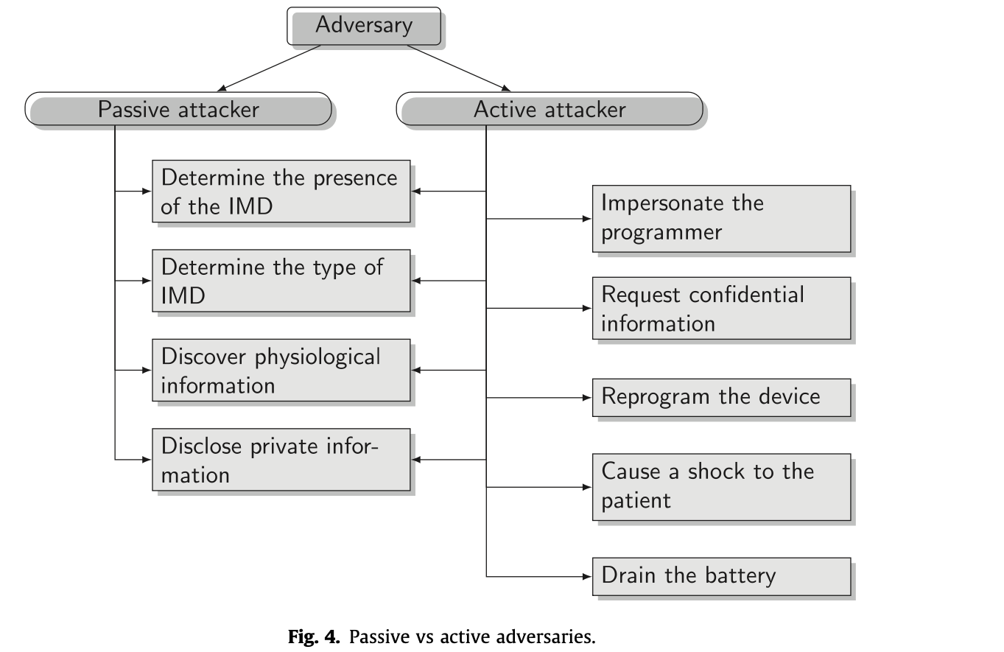

1. Implantable Medical Devices (IMDs)
IMDs are medical devices implanted into the body to manage, monitor, or treat health conditions. They range from simple biosensors to complex systems with advanced communication and decision-making capabilities.

Examples:
- Cardiac Devices:
  - Pacemakers and defibrillators: Monitor and regulate heart rhythm.
  - Advanced models include pressure sensors to detect cardiac failure risks.
- Neurostimulators:
  - Provide electrical impulses for conditions like Parkinson’s or epilepsy.
  - Target specific brain regions via deep brain stimulation (DBS).
- Drug Delivery Systems (DDS):
  - Infusion pumps deliver medication directly to specific sites, allowing precise dosing.
- Biosensors:
  - Embedded sensors monitor physiological parameters, forming networks like Intra-Body Networks (IBN).

Modern Advances:
- Wireless communication (telemetry) enables remote monitoring and adjustments.
- Supports cost-efficient, continuous care and diagnostic advancements.
- Examples: Programmers communicate with IMDs to send commands, update therapies, or retrieve patient data.

2. Risks and Impacts of Cyberattacks

Security Threats:
- Confidentiality: Rasmussen et al. (2010)
  - Wireless transmissions expose IMDs to eavesdropping.
  - Attackers can detect device presence, access medical data, or identify IMD models.
- Integrity: Walker et al. (2014)
  - Forging or altering transmitted data can result in harmful medical decisions or device misbehavior.
- Availability: Gollakota et al. (2011)
  - Denial of Service (DoS) attacks can disable IMDs by overloading communication or draining the battery.

Consequences:
- Health Risks: Dick Cheney's Case (2013)
  - Disabling critical therapies or sending harmful commands.
  - For example, lab experiments demonstrated attackers inducing shock states in defibrillators.
- Privacy Breaches:
  - Patient medical data and location information can be exposed.
- Battery Drain: Kaadan and Refai (2015)
  - Malicious activities like flooding the IMD with network traffic can force premature replacements via surgery.

3. Preventive Measures
To mitigate risks, IMDs must uphold Confidentiality, Integrity, and Availability. The key measures include:

1. Cryptography:
- Kaadan and Refai (2015) developed a military-grade cryptographic system combining one-time pads and novel key distribution mechanisms for IMDs​
- Camara et al. (2015) argue for lightweight cryptographic protocols tailored to IMDs’ resource constraints
- Challenges: Key management and potential computational overhead.

2. Authentication:
- Ensures only legitimate entities (e.g., authorized medical personnel) interact with the IMD.
- Mutual authentication between devices ensures trustworthiness. Gollakota et al. (2011)

3. Access Control:
- Prevents unauthorized actions like reprogramming or data access.
- Can be implemented using Public Key Infrastructure (PKI) or Access Control Lists (ACLs).
- Hei and Du (2012) proposed using multi-level biometric authentication for access control to IMDs, combining fingerprint and iris-based system

4. Logging and Auditing:
- Logs track all device interactions, deterring malicious actions.
- Limited IMD memory necessitates external storage solutions.

4. Limitations and Design Trade-Offs
IMDs face unique challenges due to their resource constraints.

Technological Limitations:
- Energy:
Warwick et al. (2015) advocate for predictive energy management in neurostimulators to extend battery life, ensuring only necessary stimulations are activated​
  - Powered by integrated batteries, often lasting 8–10 years.
  - Communication tasks consume significant power, shortening battery life.
- Storage:
  - Limited memory prioritizes medical data over security functions.
  - Example: Cardiac devices allocate up to 75% of memory for ECG signals. Camara et al. (2015)
- Computing Power:
  - Small microcontrollers restrict computationally intensive security solutions. Rasmussen et al. (2010)

Critical Trade-Offs:
- Security vs. Safety:
  - Strong security may delay emergency responses. For instance, bypassing encryption might be needed for urgent device access.
  - Camara et al. (2015) stress the critical need to balance robust security with accessibility during emergencies, such as disabling authentication in urgent scenarios​
- Battery Life vs. Functionality:
  - Balancing energy usage between security measures and medical tasks is essential.
  - Kaadan and Refai (2015) show that low bit-rate, energy-efficient communication protocols are more practical for IMDs than high-speed data exchanges​
- Latency:
  - Security protocols must operate within acceptable time limits to ensure patient safety.

5. Proposed Solutions
- Access Control:
  - Certificate-Based: PKI enables device authentication using digital certificates.
  - Proximity-Based (Rasmussen et al. (2010)): Limits device access to physically close entities, though vulnerable to manipulation.
- External Devices:
  - Devices like cloakers mediate IMD interactions, offloading security tasks.
  - Risks include loss, damage, or malicious replacements.
  - Gollakota et al. (2011) introduced the "shield," a device that jams unauthorized signals, ensuring only legitimate communications reach the IM
- Biometrics:
  - Authentication using patient-specific traits (e.g., fingerprints, iris scans).
  - Hei and Du (2012) suggest two-tiered biometric systems, using basic and advanced patient characteristics to ensure both security and accessibility in emergencies​
- Auditing:
  - Continuous logging of all actions, aiding in attack detection and forensic analysis.
  - Camara et al. (2015) argue that IMDs should always prioritize safety over security in emergency situations, allowing unrestricted access in critical cases​

6. Regulatory and Engineering Recommendations

Regulatory Challenges:
- FDA Guidelines (2015): Emphasize integrating security mechanisms like encryption and secure key management into wireless IMDs​.
- Camara et al. (2015) advocate for mandatory security evaluations before IMD approvals, akin to drug trials

Design Principles:
- Security-by-Design:
Integrate robust security mechanisms during the design phase.
- Fail-Safe Systems:
Emergency protocols must prioritize patient safety without exposing security vulnerabilities.

7. Open Issues and Future Directions
- Emergency Access:
Camara et al. (2015) highlight the need for adaptive security mechanisms that dynamically relax or tighten controls based on situational contexts​
- Energy Optimization:
Wang and Song (2010) propose using mechanical energy from body movements to power IMDs, reducing reliance on fixed batteries
- Adaptive Security:
Rasmussen et al. (2010) emphasize real-time monitoring systems that adjust security levels based on detected threats
.

